What Leaders Do?
Insights Into Why Leadership Development Is So Challenging

Article by Elizabeth Mills, Attorney at Law, Inzer, Haney & McWhorter, P.A.
Herb Rubenstein, Esquire, Founder and Executive Director, THE LEEEGH, INC., and
Author, Leadership for Lawyers, 2nd Edition, American Bar Association (2008)

Introduction

Successful leadership requires that a person be able to analyze a current situation, understand enough of its history to see why the challenging situation is the way it is, and identify and deploy the right kinds of resources to bring to bear to help solve the challenge. If leadership were as easy as these three steps, all of us would be better leaders.

This article describes some of the key behaviors that leaders need to deploy in order to be successful. Leadership skills and acumen can be learned and can be taught. The idea that someone is born a leader is just as sensible as a person is born an Olympic Gold Medalist. To win a gold medal, one needs to train, have superior coaching, and hone their skills. To be a successful leader, one also needs to train to be a leader. People can train “on the job” or “through the school of hard knocks,” but this form of training is haphazard and takes decades. Excellent leadership training can shorten the time and reduce the pain that people go through in improving their leadership skills. Every element of leadership cannot be learned in the classroom, just as one cannot become successful in any endeavor just by sitting in the classroom. Experience is important, especially those types of leadership experiences that are well planned and based on a solid strategy.

Leadership Behaviors

Leadership behaviors are multidimensional and cannot always be quantified. However, leadership behaviors have three characteristics in common. The leader must be cognitive, active, and inspirational. Highly successful leaders are able to recognize their surroundings and circumstances. Accordingly, they are able to take appropriate action or non-action, if called for, and then inspire others (sometimes softly and sometimes strongly) to be led.

Below, we identify key leadership behaviors. Regarding many of these behaviors we will list them not as a single behavior. Rather, we list them as a continuum or a dimension of related behaviors that span a particular area of human behavior. One should not view these behaviors as contradictory in any manner. For example, a leader must know when and how to be persistent. And a leader must know when and how to be patient. These terms, persistent and patient, should be viewed as complementary, not as opposites. Recognizing and knowing when to be persistent (most of the time), and when to be patient, (when the situation dictates that a leader to be patient) are both key elements of being a leader. The goal of listing these behaviors is to help raise your consciousness as you seek to become a better leader or to evaluate others who lead in a particular situation. Whether you are mentoring someone, or just yourself, this list of behaviors can become a checklist for you to observe yourself or others and to guide you to becoming a better leader.

LEADERS ARE PEOPLE WHO……………………………

Are decisive when appropriate Are patient when necessary
Inspire others to achieve greatness Motivate themselves constantly
Promote greatness in others Hold others accountable for actions
Take charge Delegate
Serve Pick their battles
Outgoing and energetic Thoughtful and Insightful
Strength and courage Wary and doubtful when appropriate
Willing to sacrifice for others Willing to ask others to sacrifice for them
Aware of their surroundings Able to ignore/overcome barriers
Desire to control Willing to work as a team members
Listen to others Speak to others
Understands the meaning of what is being said Communicates forcefully
Understands why things occur Is future-centric, not history-centric
Build consensus Takes charge when necessary
Collaborative Uses experts to solve technical problems
Not afraid of failure Hates failure
Accepts responsibility Shares responsibility
Has vision, can set goals Excellent tactician
Can form strategic plans to achieve goals Acts unilaterally without a plan when necessary
Ability to recognize and accommodate weakness Does not tolerate weaknesses well
Recognizes where group lacks knowledge and skill Plays to the strengths of the group
Are great followers Are great leaders
Understand and communicate “what is in it for you” Build high level purpose for the group, others
Has optimism Is a realist
Has and promotes credibility Is able to attack lack of credibility successfully
Can effectuate change Knows not to try to change everything

Can successfully maintain status quo as needed Can show others benefits of change
Conciliatory Demanding
Responds well Is proactive
Garners discoveries and uses discoveries Relies on verified, useful information
Manages conversations and does not dominate them Leads with probing questions
Conclusion
Leadership is complex. Mastering the categories of behaviors allows leaders to be flexible in building the right kinds of behaviors for the right kinds of situations. This article has laid out many of the behavioral dimensions of successful leadership behavior. There are many additional categories of behaviors that leaders undertake to assist them in leading themselves and organizations. We hope you find this article useful in improving your leadership skills and abilities.
About The Authors
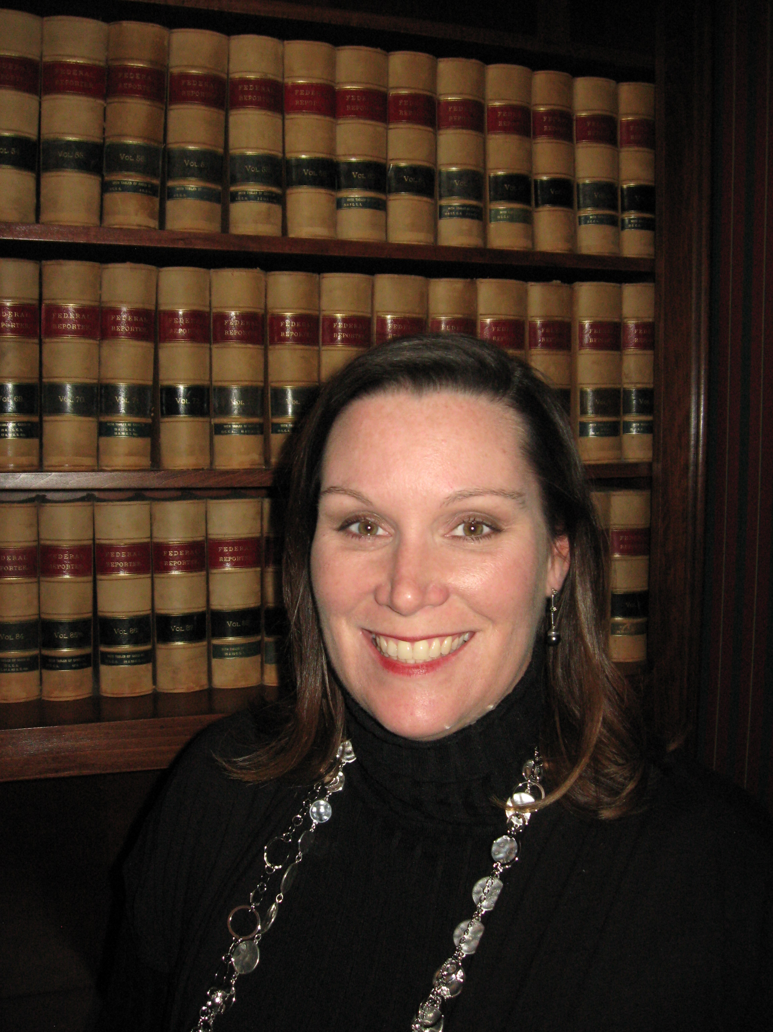
Elizabeth Haney Mills is a partner with the Law Firm of Inzer, Haney & McWhorter, P.A. in Gadsden, Alabama. She is a 1993 graduate of Emory University with a B.A. in International Politics, a 2004 Honors Graduate of the Birmingham School of Law, and most recently a 2011 graduate of the Alabama State Bar Leadership Forum. Ms. Mills serves her local bar association and community in several leadership positions. Her email is ehmills@bellsouth.net and her phone number is 256-546-1656.



Herb Rubenstein is an attorney and the Founder and Executive Director of THE LEEEGH, a nonprofit organization which stands for leadership in education, energy, environment, governance and health. He is also the CEO of the Sustainable Business Group, Inc., a leadership and management consulting firm. He is the lead author of Leadership Development for Educators (Rowman and Littlefield, December, 2008, US Publication; Overleaf Publishers, March 2010, India Publication). He is co-author of Breakthrough, Inc. – High Growth Strategies for Entrepreneurial Organizations (Prentice Hall/Financial Times, 1999) and author of Leadership for Lawyers (American Bar Association, 2008). He serves as an adjunct professor of strategic management at the University of Colorado Denver in the graduate Global Energy Management Program and has taught strategic management in the MBA program at George Washington University. He has also served as an Adjunct Professor of Entrepreneurism at George Mason University and Colorado State University, is a founding director of the Association of Professional Futurists, and is the author of over 100 articles and 80 videos on leadership, governance, and strategic planning. He has his law degree from Georgetown University, his Master of Public Affairs from the LBJ School of Public Affairs, a graduate degree in sociology from the University of Bristol in Bristol, England and was a Phi Beta Kappa/Omicron Delta Kappa graduate from Washington and Lee University in 1974. His email herb@sbizgroup.com and he can be reached at 303 279-1878. For more information about THE LEEEGH, see www.theleeegh.org, and for information about his books, see www.leadershipforeducators.org and www.leadershipforattorneys.org. For more information about the Sustainable Business Group, see www.sbizgroup.com.

